新北市立新北高工 一O七 學年度第 一 學期 第一次段考 |  |  |  |  |  |  |  | 班級 |  | 座號 |  | 成
科目 | English | 年級 | 一 | 科別 | 機鑄汽訊電資 |  |  | 姓名 |  |  |  | 績
- 聽力（每題1分，共10%）  第一部分：看圖辨義 (唸兩遍)  請參照上的圖片，聽一個和該題相關的問題，與(A)、(B)、(C)三個英語敘述後，選一個與所看到圖片最相符的答案。  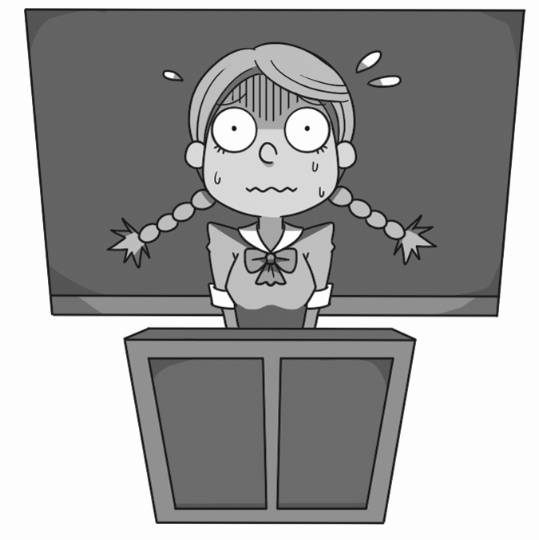    2. ____________________  第二部分：問答（唸兩遍）  1. ______________________  每題會播出一個問句或直述句，聽後請由試卷上(A)、(B)、(C)三個選項中，選出一個最適合的回答或回應。  3. (A) It starts at 5:30.  (B) We will eat soup and meatballs.  (C) Only three of them.  4. (A) When I was five.  (B) I got this piano four years ago.  (C) They cost NT$10,000.  5. (A) Not at all. That was my best friend!  (B) Yes, more people came later.  (C) He came up with a new idea. |  |  |  |  |  | 第三部分：簡短對話（唸一遍）  每題會播出一段對話及一個相關的問題，聽後請由試卷上(A)、(B)、(C)三個選項中，選出一個最適合的回答。  6. (A) On television.  (B) On the Internet.  (C) The girl sang it for him.  7. (A) Because he plays the guitar.  (B) Because it’s stuck in his head.  (C) Because he likes the sound of the guitar.  8. (A) The date of the gathering.  (B) The place of the gathering.  (C) The starting time of the gathering.  第四部分：短文聽解 (唸一遍)  每題有三個圖片選項。請聽題目，並選出一個最適當的圖片。  9. (A) (B) (C)  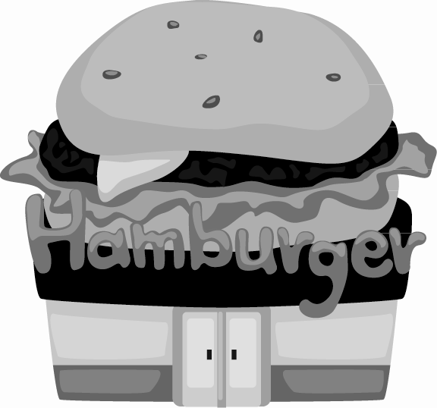  10. (A) (B) (C)  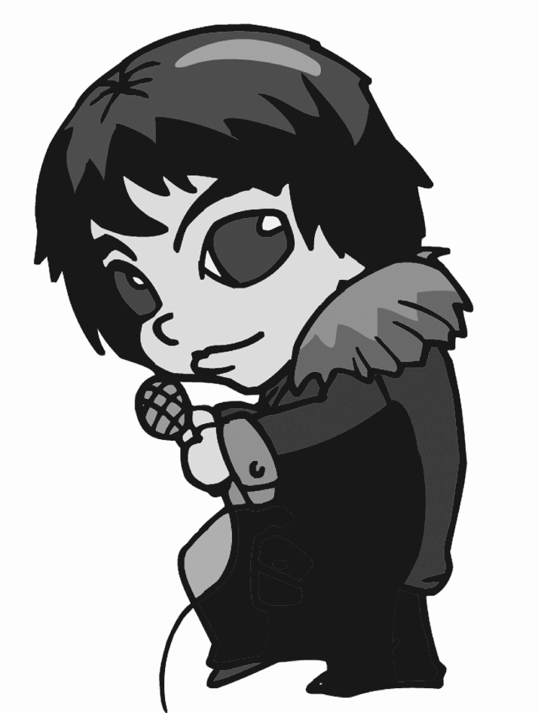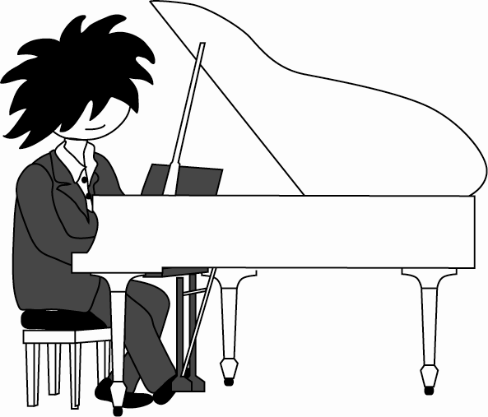
新北市立新北高工一O七 學年度第 一 學期 第一次段考 |  |  |  |  |  |  |  | 班級 |  | 座號 |  | 成
科目 | English | 年級 | 一 | 科別 | 機鑄汽訊電資 |  |  | 姓名 |  |  |  | 績
- 綜合文法 （每題2分，共20%）  11. If you like the girl, why _____ her?  (A) not telling (B) not to tell (C) not tell (D) don’t tell  12. Our teacher asked some students to move the desks away and ordered _____ to mop the floor.  (A) another (B) other (C) others (D) the other  13. _____ his hands, the young man created many toys for his children by himself.  (A) For (B) With (C) From (D) Into  14. It looks _____. We have to hurry up.  (A) rains (B) raining (C) like rain (D) rain  15. People became _____ when their team won first place in the Olympic Games.  (A) excited (B) excitedly (C) exciting (D) excite  16. The teacher assigned me _____ an elephant by tomorrow. I’m not sure if I can do it.  (A) draw (B) drawing (C) to draw (D) drew  17. This new game is very popular _____ teenagers.  (A) with (B) into (C) for (D) from  18. _____ today’s technology, people now can talk to one another more easily, so the world _____ a  smaller place.  (A) With; feels like (B) For; feels (C) With; looks (D) As; feels like  19. There _____ many beautiful flowers in this garden in the past, but now they _____ all gone.  (A) are; will be (B) were; will be (C) were; are (D) are; were  20. For children in Taiwan, Chinese New Year _____ usually _____ lucky money and big dinners.  (A) is; associated with (B) gets; stuck (C) takes; away (D) walks; by  - 克漏字（每題2分，共20%）  It is not easy to plan a party. Cathy wants to invite some friends __21___ for a Christmas party. But she does not want to prepare everything __22__ herself, so she is telling each friend what to bring. She __23___ them to bring pasta, pizza and fried chicken. Now, she is talking with her best friend, Annie, ___24__ the phone. “What do you want to bring?” But Annie doesn’t want to tell her, she says it will be a __25___. Cathy will know the answer on the day of the party.  21. (A) to (B) on (C) over (D) up  22. (A) on (B) by (C) in (D) at  23. (A) prepares (B) reads (C) enters (D) assigns  24. (A) on (B) by (C) in (D) at  25. (A) guest (B) surprise (C) fair (D) potluck |  |  |  |  |  |  | Do you listen to old songs? Are you familiar __26___ the song “You Are My Sunshine?” Most of you will answer “yes.” Although it is an old song from the 1940s, __27___ it is still very popular today. It is widely used in many commercials. In the Uni-President soy milk commercial, for example, the soy milk __28___ “the morning sunshine at the beginning of a day.” Music is an important part in TV commercials. Catchy tunes can easily get __29___ in people’s heads, and thus create a brand image in their minds. Moreover, music helps __30___ a mood in a commercial. The best example is “Close to You” used by Volkswagen. The car company used the song to express the idea of getting closer to their customers.  26. (A) as (B) for (C) to (D) with  27. (A)× (B) but (C) so (D) because  28. (A) just like (B) is like (C) like (D) likes  29. (A) sticking (B) to stick (C) stuck (D) stick  30. (A) created (B) creating (C) to create (D) creates  四. 對話（每題2分，共10％）  31. Host: Please make yourself at home.  Guest: Thank you. _____  Host: Sure. Just go down the stairs and you will see it.  (A) May I have some water? (B) May I use the restroom?  (C) I would like to have something to eat. (D) Can I take some pictures with you?  32. Amy: It’s a great party and the chicken really tastes good.  Lily: Well, I think it tastes a little bland. _____  Amy: Sure. Here you are.  (A) Did you see the host? (B) Help yourself to the food.  (C) Would you pass the salt, please? (D) I’ll talk to you later.  33. Justin: Michael, are you enjoying the party?  Michael: Yes, of course! It’s a great party. You did a lot of work to get ready.  Justin: Yes, and so did my cook! _____ There are many delicious dishes prepared especially for  this party.  Michael: Sure! I’ll try the tiramisu.  (A) Please bring me some food. (B) Help yourself to the food.  (C) You look thirsty. (D) Talk to you later.
新北市立新北高工一O七 學年度第 一 學期 第一次段考 |  |  |  |  |  |  |  | 班級 |  | 座號 |  | 成
科目 | English | 年級 | 一 | 科別 | 機鑄汽訊電資 |  |  | 姓名 |  |  |  | 績
34. Jeffrey: Hi, Susan. _____  Susan: I am worried about my cat Furry. I can’t find her and I think she is lost.  Jeffrey: Don’t worry. We can look for her together.  Susan: Thank you, Jeffrey! You are such a nice person.  (A) What’s that? (B) How is the weather?  (C) How about that? (D) What’s up?  35. Rex: Hey, Mona. I’m thinking of going to a movie. Would you like to come?  Mona: _____  (A) Oh... uh, sorry, I’m afraid I’m busy tonight. (B) Anyway, thanks for asking.  (C) You’re telling me. (D) Don’t mention it.  五.閱讀測驗（每題2分，共10％）  A host should make a clear and detailed plan before a party. The following is a brief example of a party planning list. Three weeks before the party, the host should make a list of people to invite, and decide on a theme for the party. Then the host can use mail, e-mail, or phone to invite people. As for the food, the host plans the menu and makes a shopping list.  Two weeks before the party, the host should clean items such as glasses or china all around the house. One week before the party, the house needs cleaning, and the furniture should be rearranged for the party so that guests can move around easily. Also, a first round of grocery shopping and cooking can be done at this time. Three days before the party, to be polite the host should tell his or her neighbors about the party. Then, he or she can put up theme decorations* or arrange candles. The host then finishes all the grocery shopping and makes a detailed cooking schedule for the remaining dishes.  On the day before the party, the host sets the table and finishes as much of the cooking as he or she can. Then on the day of the party, the host finishes any last-minute cooking, places chairs and displays the food. Last but not the least, the host greets the guests as they arrive.  ＊theme decorations 主題裝飾  36. Which of the following is the best title for this passage?  (A) The Role of Surprise at a Party. (B) Arranging a Party.  (C) Shopping for a Party. (D) The Pros and Cons of a Party.  37. Which of the following should be done first before a party?  (A) Choosing a theme for the party. (B) Doing the first round of shopping.  (C) Cleaning the house. (D) Putting away precious items.  38. Why should the host tell his or her neighbors about the party?  (A) To invite them to come to the party.  (B) To ask them to leave home at that time.  (C) To be polite.  (D) To share some food with them. |  |  |  |  |  |  | 39. Which of the following should be done last?  (A) Sending out invitations. (B) Planning the menu.  (C) Rearranging the furniture. (D) Serving the food.  40. What source is this passage most likely from?  (A) A health magazine. (B) A travel guidebook.  (C) A scientific journal. (D) A homemaker’s magazine.  六.文意字彙（每題2分，共30%）  41. O_____y, we planned to go to Japan, but then we won the trip to Thailand.  42. Could you give me the r_____e for this delicious dish?  43. The Olympic Games drew an a_____e of more than 15 million people.  44. Many children asked for the Hello Kitty toy after they saw it in a TV c_____l.  45. When you have more than one child, you always have to try to be f_____r to all your children.  46. Some people want to fight, but I don’t want to get i_____ed.  47. Lady Gaga is always full of surprises. She does u_____d things and wears strange clothes.  48. In the b_____g, the team was twenty points behind, but to everyone’s surprise, they won in the  end.  49. The government is going to c_____e hundreds of new jobs for the people of the country.  50. I am already full. Can you finish the r_____t of the meal by yourself?  51. There should be no s_____ts between true friends.  52. The company can p_____e one hundred cars per hour.  53. Sally has l_____ged to become a movie star since she was a child.  54. They finally __54___ __55___ with a way to solve the problem.  他們終於想出一個方法解決這個問題。  請在本張試卷上方寫上姓名座號，將答案卷交回
  41. | 42. | 43.
  44. | 45. | 46.
  47. | 48. | 49.
  50. | 51. | 52.
  53. | 54. | 55.

